

Sessional Support Worker:
Epsom, Leatherhead & Surrey region

February 2025

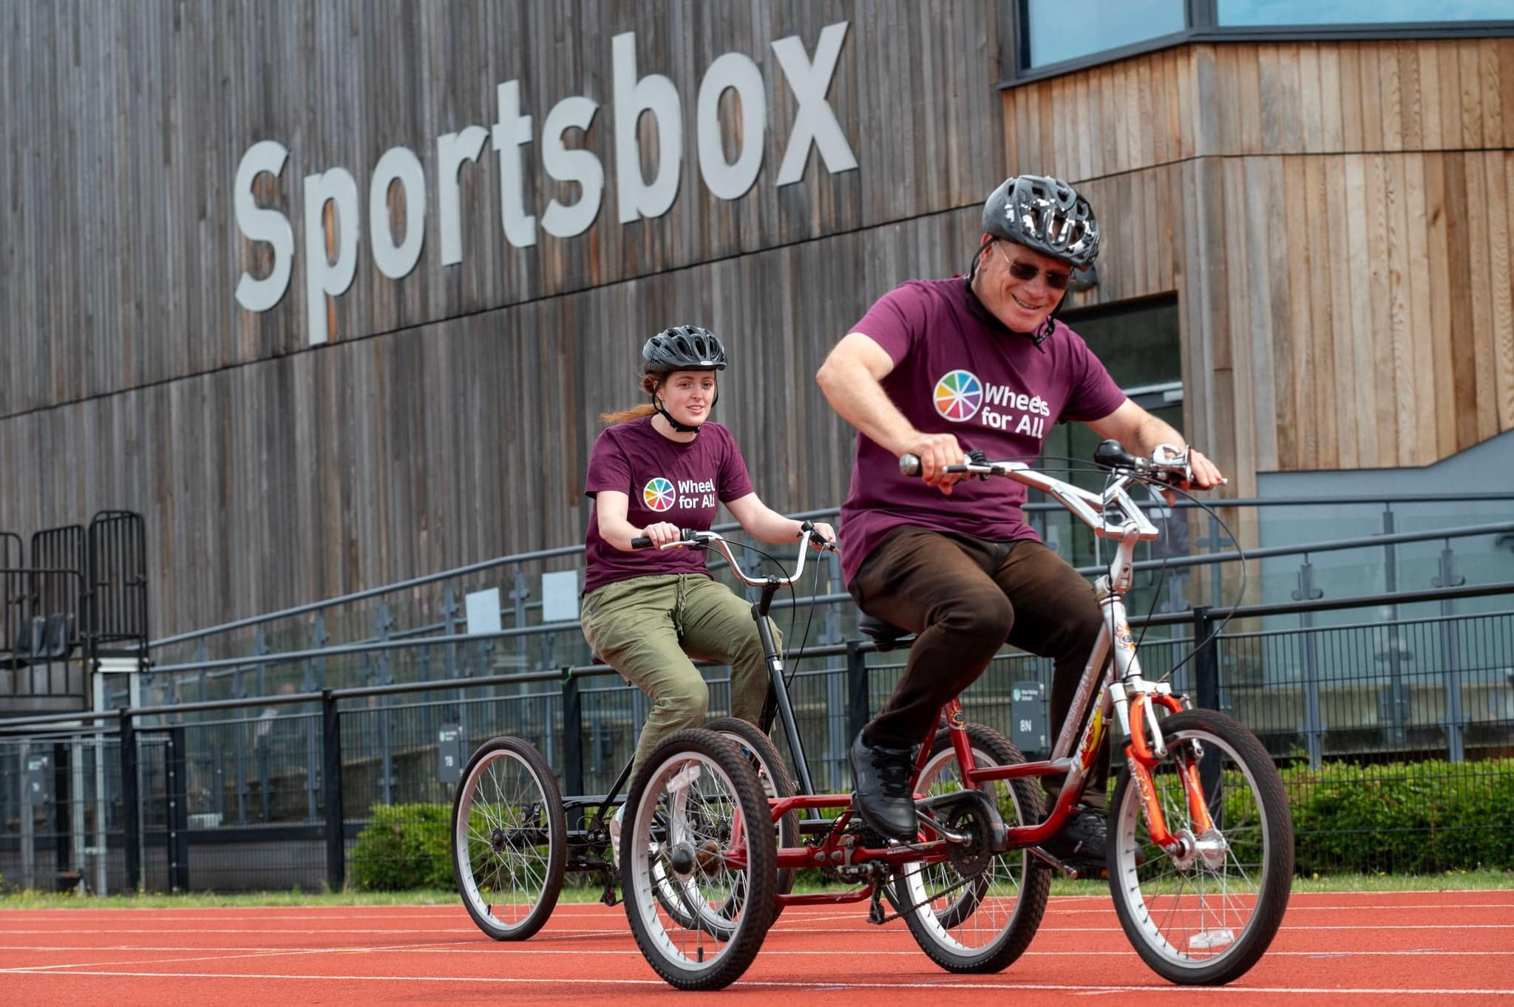

- Role summary

Title | Inclusive Cycling Sessional Support
Salary | Real Living Wage. £12 per hour (£21,840 FTE per annum) + 12.07% salary enhancement in lieu of holiday (London weighting may apply depending on home postcode)
Hours | Work programme to be agreed with Inclusive Cycling Coordinator and/ or Regional Manager. We have immediate need for support for our existing weekly programme across the region.
Contract | Zero Hours Contract
Location | To be agreed with Inclusive Cycling Coordinator and/ or Regional Manager. There are current delivery needs in Surrey at our hubs in Epsom and Leatherhead, with further work with partners across Surrey in the future as we develop new delivery partnerships. Sessional staff will be reimbursed travel expenses from their home to where they are working.
Reporting to | Inclusive Cycling Coordinator

- Staff benefits

Wheels for All is committed to the health and wellbeing of our staff. We are proud to offer these benefits to all members of our team:

- Apparel – we provide all members of staff with quality clothing to keep them looking and feeling good when out and about.
- Employee Assistance Programme - access to a 24/7 confidential helpline, counselling services and online information.

- About Wheels for All

Wheels for All (the operating name of Cycling Projects Ltd) is a leading national charity delivering accessible cycling opportunities for people to be active on their terms.

- Wheels for All was established over 30 years ago and has created the largest network of accessible cycling opportunities across the country.
- Supporting people to start and continue cycling regardless of ability.
- Working with local partners, we have supported the creation of more than 50 accessible cycling hubs, many of which are now run independently, assisted by dedicated, committed staff and volunteers.
- Wheels for All is also a national leader for accessible cycle training, providing specialist support and guidance to community initiatives and partners on setting up local inclusive cycling programmes.
- We are proud to support more people to be more active, improving their physical and mental wellbeing.
- We are committed to providing safe, enjoyable, accessible and social environments for our participants to begin and progress their cycling, whether for recreation or active travel.

We are currently in an exciting period of growth as we upscale our delivery to enable more people to enjoy the benefits of cycling.

Our new 'We Ride Together' Film captures the true spirit of the charity through powerful language and imagery by telling the story in the form of a poem about Dave, a Wheels for All volunteer and cyclist who had been recently widowed and joined the charity to help him deal with his bereavement. Loneliness is one the largest health concerns we face and people are feeling more isolated and disconnected than ever before, but Dave is proof that having a connection with others through a shared interest such as cycling can provide a happier and healthier future for all involved. Our cycling programmes are fine examples of how such communities can flourish and thrive and we should never underestimate the lifeline that the charity is to so many people.

Please watch the new film here https://www.youtube.com/watch?v=wAHYqIQqUa8

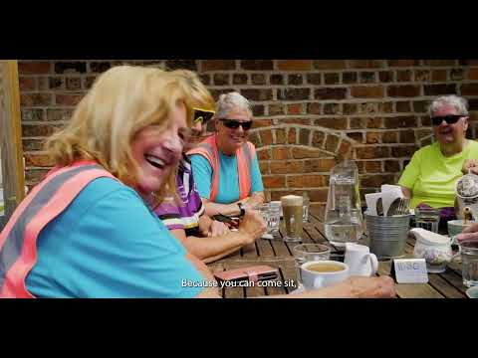

- Role overview

As a Sessional Support Worker, you will provide essential support to the delivery of inclusive cycling activities at our internal hubs.

See links here:
Wheels for All | Wheels for All — The UK inclusive cycling charity

Reporting to the Inclusive Cycling Coordinator, you will ensure that these cycling programmes meet the needs of target audiences, uphold safety standards, and contribute to the establishment of sustainable hubs.

- Role responsibilities

Inclusive cycling centres and programmes

- Assist in the delivery of inclusive cycling activities at internal hubs, and other programmes adhering to Wheels for All Ways of Working standards.
- Support the implementation of a cycling programme that caters to the needs of diverse target audiences, prioritising safety and care.
- Work professionally with partners, volunteers, and participants to create a positive and inclusive cycling environment.
- Provide support and guidance to volunteers assisting in inclusive cycling activities.
- Conduct bike maintenance as per guidelines to ensure the safety and functionality of equipment.

General:
- Lead by example and foster a positive, professional working environment.
- Adhere to Wheels for All Ways of Working, policies, and procedures.
- Be flexible with working hours and conditions, including occasional outdoor work.
- Contribute to the protection of children and vulnerable adults.
- Promote, monitor, and maintain health, safety, and security in the workplace.

Learning and Development:
- Stay informed about current inclusion and engagement campaigns.
- Complete necessary training to maintain up-to-date knowledge.

Note: This job description is subject to amendment based on experience and consultation with the post holder. It provides a general indication of duties and may vary over time.

Background Checks: As this role may involve working in regulated environments with young people, any offer will be conditional on satisfactory background checks, including criminal record checks and references.

- Person Specification:

Essential Criteria:

- Passion for promoting inclusivity and accessibility in community-based activities.
- Excellent communication skills with the ability to work effectively with diverse stakeholders.
- Commitment to upholding safety standards and ensuring the well-being of participants.
- Ability to work flexibly and adapt to changing priorities and schedules.
- Experienced and/or qualified Ride Leader, e.g. British Cycling/Cycling UK.
- Demonstrated professionalism and reliability in previous roles.
- Basic knowledge of bike maintenance or a willingness to learn.

- Application Process

Please submit your application through the candidate portal by clicking the following link: Apply Here. Upload your resume and a cover letter detailing how you meet the role's requirements.

We also welcome applications in alternative formats, such as video or audio. If applying this way, please include "Sessional Support Worker" in the subject line and send your submission to recruiting@wheelsforall.org.uk.

Applications are reviewed on a rolling basis, and the recruitment process may close once we have sufficient staff for the programme.
If you have any questions or would like to have an informal discussion
about the role, please email recruiting@wheelsforall.org.uk, call 01925 575 628 or visit our contact page.

Data protection

Wheels for All will only process and store your personal information.
(this means any information that identifies or could identify you) for the
purposes of recruitment, after which it will be securely disposed.

Equal opportunities

We welcome and encourage applications from people of all backgrounds.

Wheels for All is committed to creating an inclusive culture, through fostering a diverse workforce where everyone feels like they belong, differences are valued, and everyone can reach their potential. We are a Disability Confident Committed employer and are actively seeking to diversify and to create a workplace that is welcoming for all, ensuring that our workforce is representative of wider society and the communities we support.

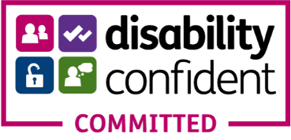 |  | 

