
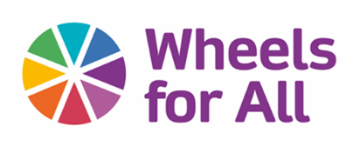
Invitation to be a partner organisation in the Greater Manchester Bike Buddy project

Wheels for All specialise in providing opportunities for people to gain access to inclusive cycling. Our ‘Bike Buddy’ programme aims to support disabled people, people with long-term health conditions and less active older-aged people to cycle, with support, in their communities.
For this project we are looking to partner with up to three organisations from across Greater Manchester to enable their staff, volunteers and participants to embrace cycling as a credible and enjoyable activity for all to enjoy.

What is Bike Buddy?
Our offer to you:
We will offer you and your organisation a period of cycling interventions and support packages that ultimately will create a sustainable cycling culture within your setting.
This will be supported by-
- A fleet of adapted cycles (tricycles, recumbents, and hand cycles).
- Helmets and Hi-Viz vests
- Lock and lights
- Cycle training for participants and carers/support workers
- Route planning
- Buddy support
- Maintenance support packages
- Participant mentoring

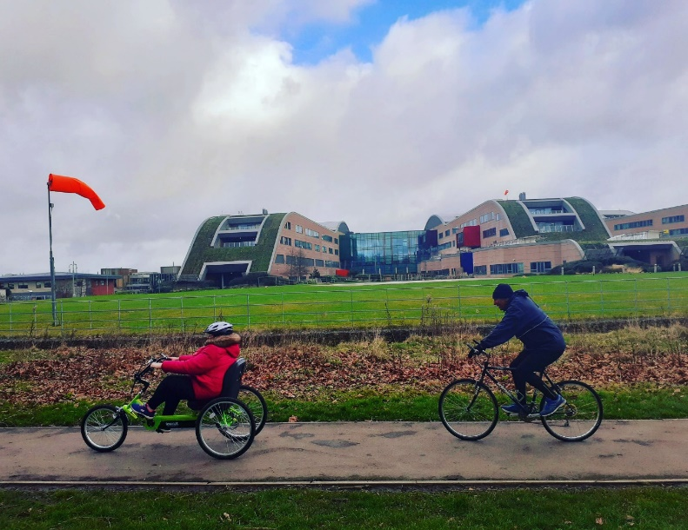
‘Bike Buddy’ is a complete programme of training, support, and provision of specialist cycles. Our goal is to engender a cycling culture within those partner organisations meaning long term access to the health, wellbeing and social benefits from service users and within those communities.

Bike buddy in action

We want to help your organisation embrace the benefits of cycling for your members, staff and volunteers, and we want to support you create a long-term culture of active travel.

If successful, you will be expected to:
- Work with Wheels for All staff to develop a ‘cycling culture’ within your organisation.
- Commit staff and/or volunteer time to participating in group and individual rides to support your service users to cycle.
- Provide a secure storage space for a fleet of adapted cycles.
- Provide agreed monitoring and evaluation data to Wheels for All about cycling activities.

What happens if my organisation is not successful?
We can still support you and your members to cycle through a variety of community-based interventions by TFGM and through a network of Wheels for All hubs across the region (see www.wheelsforall.org.uk for details).
For further information about the programme please get in contact with –
Caroline Powrie, Greater Manchester Bike Buddy Co-ordinator
caroline.powrie@wheelsforall.org.uk / 07849 853705

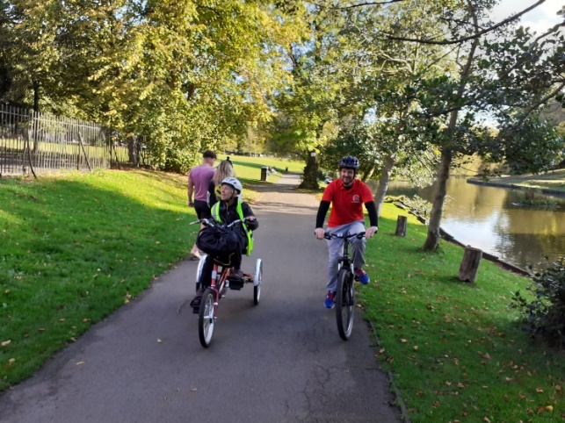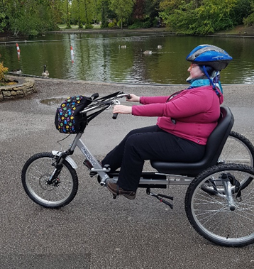
If you want to be part of this exciting project, please complete the following questions and return to caroline.powrie@wheelsforall.org.uk -
The need for Bike Buddy
Can you demonstrate a clear need that there are disabled people that you work with who want to be active and cycle?
Please give some examples.

Can you show evidence of staff and volunteers who will embrace the Bike Buddy support?
Please give some examples.

Do you have access to a wide range of routes, greenways and quiet road scenarios for cycling?

Name:

Organisation:

Contact details:

What we ask of you and your organisation
Are you willing to receive Wheels for All training to support the delivery of the programme?

Are you willing to participate in groups rides with other partners of the programme?

Are you willing to complete admin tasks as part of the data collection process?

Will you be able to allocate a staff member as the point of contact for your organisation?

Logistics
Do you have potential space on site for storage of cycles? (Please outline storage opportunities and level of security)

Do you have access to a wide range of routes, greenways and quiet road scenarios for cycling? (Wheels for All staff can help to identify these routes)

if the answer is yes then to all the above then we would like to hear from you, and we will be in touch very soon

